2026
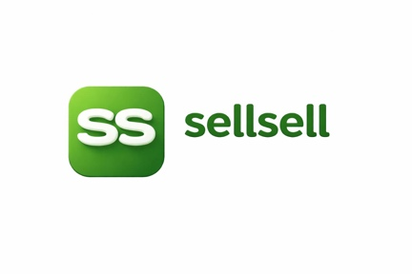
sellsell marketplace updates:

Shaz EJ
SellSell / PickPic Development Update
Date: 22 June 2026
Prepared for: Fahad
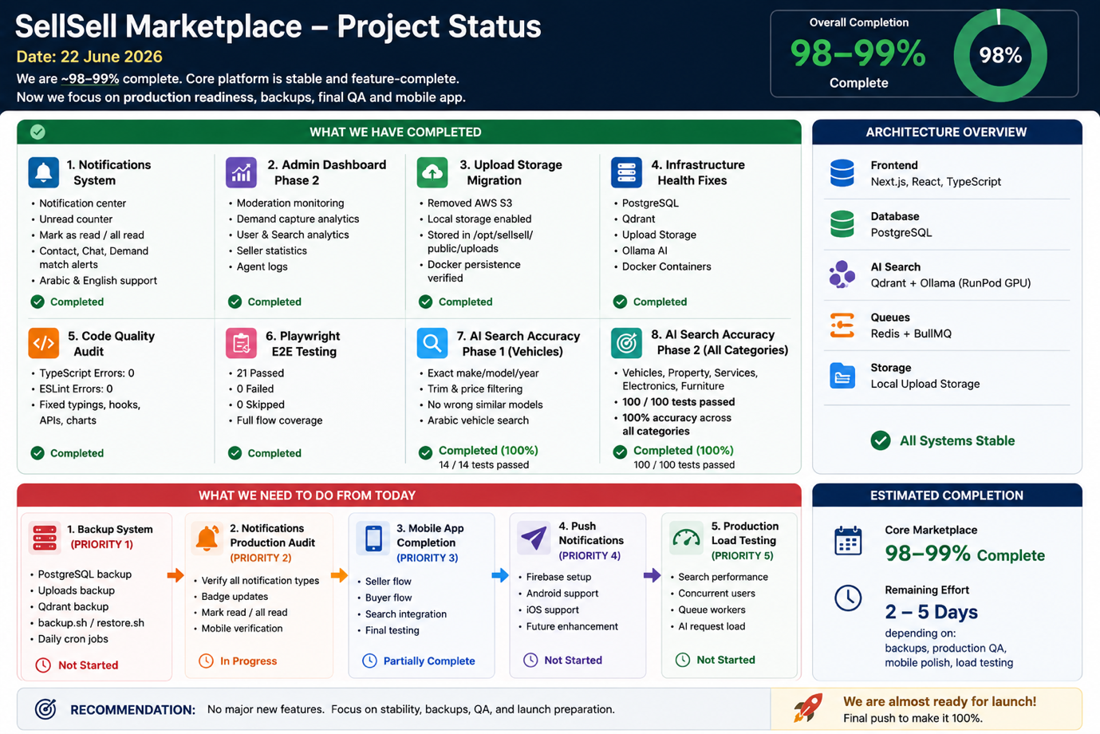

Overall Project Status
The platform is now approximately 98–99% complete from an MVP perspective.
The focus has shifted from building major features to:
- Stability
- Search quality
- Production readiness
- Backups
- Final QA
- Mobile app completion

Completed This Week

1. Notifications System ✅
Implemented a complete notifications system.

Features
- Notification center page
- Unread notification counter
- Mark as read
- Mark all as read
- Contact click notifications
- WhatsApp click notifications
- Chat message notifications
- Demand match notifications
- Desktop notification badge
- Mobile notification badge
- Arabic and English support

Status
Completed

2. Admin Dashboard Phase 2 ✅
Implemented marketplace monitoring dashboard.

Features
- Moderation monitoring
- Demand capture analytics
- User analytics
- Search analytics
- Seller statistics
- Agent logs

Status
Completed

3. Upload Storage Migration ✅
Removed dependency on AWS S3.

Completed
- Local storage enabled
- Images stored in:
/opt/sellsell/public/uploads
- Docker persistence verified
- Restart persistence verified
- Production uploads verified

Status
Completed

4. Infrastructure Health Fixes ✅
Fixed unhealthy services.

Verified
- PostgreSQL
- Qdrant
- Upload storage
- Ollama AI
- Docker containers

Production Health
Database Healthy
Qdrant Healthy
Storage Healthy
AI Healthy

Status
Completed

5. Code Quality Audit ✅
Entire codebase audited.

Results
TypeScript Errors: 0
ESLint Errors: 0

Completed
- Removed unsafe typings
- Fixed lint issues
- Fixed React hook violations
- Fixed API typing issues
- Fixed chart typing issues

Status
Completed

6. Playwright E2E Testing ✅
All end-to-end tests updated.

Results
21 Passed
0 Failed
0 Skipped

Tested
- Registration
- Login
- Seller flow
- Buyer flow
- Search
- Product creation
- Settings
- APIs

Status
Completed

7. AI Search Accuracy Phase 1 ✅
Vehicle search accuracy overhaul.

Examples
User searches:
Mercedes E200
Returns:
Mercedes E200
Does NOT return:
Mercedes E300
Mercedes S500
Mercedes C200

Supported
- Make
- Model
- Year
- Trim
- Price range
- Arabic vehicle names

Result
14/14 tests passed
100%

Status
Completed

8. AI Search Accuracy Phase 2 ✅
Expanded search accuracy across all marketplace categories.

Categories Covered

Vehicles
- Toyota Prado
- BMW X5
- Mercedes E200
- Jeep Wrangler

Property
- Villa
- Apartment
- Studio
- Chalet
- Rent
- Sale

Services
- Electrician
- Plumber
- AC Technician
- Moving Services
- Cleaning Services

Electronics
- iPhone
- Samsung
- Laptops
- TVs
- Gaming Consoles

Furniture
- Sofa
- Bed
- Wardrobe
- Desk
- Dining Table

Results
Vehicles 100%
Property 100%
Services 100%
Electronics 100%
Furniture 100%

Overall:
100/100 Tests Passed

Status
Completed

Current Architecture

Frontend
Next.js
React
TypeScript

Database
PostgreSQL

AI Search
Qdrant
Ollama
RunPod GPU

Queues
Redis
BullMQ

Storage
Local Upload Storage

Status
Stable

Remaining Work

Priority 1 — Production Backup System
Need to implement:

PostgreSQL Backup
backup.sh
restore.sh

Uploads Backup
/opt/sellsell/public/uploads

Qdrant Backup
Vector database backups.

Scheduled Cron Jobs
Daily automated backups.

Status
Not Started

Priority 2 — Final Notifications Production Audit
Need production verification of:
- Notification center
- Contact click alerts
- Chat alerts
- Demand match alerts
- Badge updates

Status
In Progress

Priority 3 — Mobile App Completion
Need final work on:
- Seller flow
- Buyer flow
- Search integration
- Testing

Status
Partially Complete

Priority 4 — Push Notifications
Future enhancement.

Platforms
- Firebase
- Android
- iOS

Status
Not Started

Priority 5 — Production Load Testing
Need to test:
- Search performance
- Concurrent users
- Queue workers
- AI requests

Status
Not Started

Estimated Project Completion

Core Marketplace
98–99% Complete

Remaining Effort
2–5 days
depending on:
- Backup system
- Production QA
- Mobile polish
- Load testing

Recommendation
No major new features should be added now.
Focus should be:
- Backup system
- Production verification
- Mobile app completion
- Launch preparation
The AI marketplace, seller flow, moderation, notifications, admin dashboard, search engine, infrastructure, and storage systems are now largely complete and stable.

